Metricell V4
Example User Guide
Operational guide for the V4 web platform
Example capability baseline: V4 / 0.41.2
Prepared: September 2026
This is an example working document. Labels, permissions, available data and URLs may differ by environment.

Document History
Version | Date | Description | Author
0.1 | September 2026 | Example V4 guide created from the supplied VodafoneThree guide structure. | Metricell QA
0.2 | — | Update after review against the target deployment. | —

Purpose and scope
Metricell V4 is a browser-based workspace for visualising, investigating and planning against network, coverage, measurement and operational data. This guide gives new users a practical route through the main modules and explains what a successful interaction should look like.
It is an example rather than a contractual product specification. Feature visibility depends on deployment, permissions, available data and the current release. Use the labels shown in the application when they differ from this document.

Safe operating principles
- Use only the account and environment provided for your work.
- Treat map results and API audit entries as evidence to investigate, not proof of root cause on their own.
- Do not create, edit or delete administrative records unless an approved admin procedure requires it.
- When a screen is empty, loading or permission-limited, record the state rather than changing data to make it populate.

1. Accessing the platform
Open the V4 environment in a supported browser and use the organisation’s normal authentication flow. The exact URL and identity-provider screens are environment-specific.
- Open the supplied V4 URL.
- Enter your work email and select Next, Continue or the equivalent action.
- Complete password and any required multi-factor authentication.
- Confirm that the launcher appears, or use the main menu to return to it.
[Screenshot placeholder – Figure 1]
Insert an approved screenshot showing the organisation’s login flow and post-login launcher.
Figure 1 – Example login and launcher screen

2. Launcher and navigation
The launcher presents modules as cards. Select a card by its visible name; card order can change between releases.
Area | Typical purpose | Notes
Launcher | Open the main V4 modules. | Cards may be hidden or disabled by permission.
User menu | View account or profile actions. | Available actions vary by role.
Main menu | Move between modules or return to launcher. | Use visible labels rather than fixed position.
Module header | Open module-specific actions and view controls. | Some controls appear only after data loads.

3. GIS workspace
GIS combines a searchable layer catalogue, map controls, feature details and saved or shared views. The catalogue is organised into groups such as Network, Tests and Measurements, Improvement Areas and Planning.

3.1 Add and inspect a layer
- Open GIS from the launcher.
- Use Search layers or expand a category.
- Select a layer to add it to Map layers. Use eye, settings or remove controls as needed.
- Wait for the map and legend to finish loading.
- Select a feature to open details in the persistent panel below the map. Multiple detail tabs can remain open.
Layer group | Examples
Network | Magnet Sites, Femto Cells, Incident Reports, Predicted Coverage, Site Finder, Hotspot Hours, Network and Site Faults
Tests and Measurements | Beacons, Crowd, Surveyor
Improvement Areas | Coverage Gap Candidate Areas
Planning | Demand Scoring, Proposed Development, Site Search Area, Beacon Chunks, Prospective Sites, Unwind Polygons
Data Management | Authorised custom datasets, where available

[Screenshot placeholder – Figure 2]
Insert an approved screenshot showing the catalogue, map and bottom details panel.
Figure 2 – Example GIS layer catalogue and details panel

3.2 Surveyor and map dialogs
Some GIS layers expose an in-page filter or configuration dialog. Surveyor can offer a Select survey dialog with Username, Survey name, From and To filters, followed by Apply search, Clear, Cancel and Apply. Confirm that the dialog is loaded; it is not necessarily a new browser tab.

3.3 Planning layers
Planning includes Beacon Chunks, Unwind Polygons, Prospective Sites and Site Search Area. Availability and write permissions are deployment-specific. Use read-only inspection unless an approved planning procedure says otherwise.

3.4 Saved and shared views
Use view or snapshot controls to save a useful map state where available. Before sharing, check that the view does not expose information outside the intended audience.

4. Agentic AI
Agentic AI helps users investigate a described issue and relate evidence to network sites on a map. Multiple conversation tabs can retain each investigation’s draft, run state and map settings.
- Open Agentic AI and select the required agent when available.
- Describe the issue, affected site or location and customer impact.
- Use Attach when supporting files are permitted and relevant.
- Select Run and wait for the response, evidence and map state to finish loading.
- Use site and technology filters to focus results; the 0.41.2 baseline restricts matching to 4G, 5G SA and 5G NSA.
- Keep separate investigations in separate conversation tabs.
[Screenshot placeholder – Figure 3]
Insert an approved screenshot showing the prompt, conversation tab and resulting map/evidence view.
Figure 3 – Example Agentic AI investigation

5. RPO
RPO provides task and operational views for radio planning or related work. Depending on deployment, it may include Tasks, Actions and Audit Log with filtering and sorting.
- Open RPO from the launcher.
- Choose Tasks, Actions or Audit Log.
- Use filters and sorting to narrow the work.
- Open a record only with permission and a defined reason.
- If the service returns an empty or error state, record it; do not create test records just to populate the page.

6. Data Management
Data Management is the current V4 name for the former Custom Datasets area. Where enabled, it supports CSV import, inferred schema and location detection, visibility settings, legend customisation, geographic preview and authorised use in GIS.
Activity | What to check
Import | File format, required columns and upload result.
Schema and location | Detected column types, coordinates or address fields and warnings.
Visibility | Personal, group or global visibility matches the intended audience.
Legend | Labels, matching values and colours are meaningful.
GIS preview | Geographic features appear in expected locations.

If no dataset is available for the account, leave this workflow as not available rather than fabricating data.

7. Other modules
Module | Example use
Dashboards | Review prepared operational or performance views.
Customer Care | Open permitted customer or service investigation views.
Survey Analyser | Review survey-related analysis where enabled.
Documents | Open or manage permitted supporting documents.
API Request Audit | Inspect recorded browser, mobile, service or external OAuth traffic.
Access / Device / Agentic AI Administration | Administrative configuration and monitoring; use navigation-only inspection unless authorised.

8. API Request Audit
API Request Audit helps connect a visible product problem with a route, method, status, caller type, authentication state or OAuth client.
- Open API Request Audit from the launcher or user menu.
- Choose live or historical inspection where available.
- Filter by time, module, method, caller type, caller, status, authentication, OAuth client or route.
- Use Request Explorer or the request table to inspect a matching entry.
- Treat “unmatched” as an audit classification; it does not by itself mean that a wrong URL was used.
- Capture method, URL, status, timestamp and caller context when reporting a failure.
[Screenshot placeholder – Figure 4]
Insert an approved screenshot with sensitive identifiers redacted.
Figure 4 – Example API Request Audit investigation

9. Troubleshooting
Symptom | Suggested check
Launcher card missing | Confirm account, deployment and permission; card order can change.
GIS still loading | Wait for workspace and map style, then retry once.
Layer is empty | Check zoom, date/filter settings, data availability and permissions.
Unexpected dialog or tab | Check whether the action opened an in-page panel or a new browser tab/window.
API entry shows 5xx | Record the exact route and status; investigate the service condition.
Saved view does not restore | Confirm the view was saved and referenced layers still exist.

10. Quick reference for support
When escalating a problem, include:
- Environment URL and date/time including timezone.
- Module, visible screen and action being attempted.
- Account role or permission context; never share passwords or MFA codes.
- Exact visible error or empty-state message.
- API method, route and status when shown in API Request Audit.
- Whether the problem reproduced after one controlled retry.
- A redacted screenshot when it adds useful evidence.

Appendix A – Example verification checklist
Check | Expected result | Status
Login | Authentication completes and launcher is visible. | Not run
Launcher | Expected cards are visible by name. | Not run
GIS | A permitted layer can be opened and inspected. | Not run
Agentic AI | A permitted investigation can be submitted and reviewed. | Not run
RPO | Permitted read-only views load. | Not run
Data Management | Actual dataset availability is recorded. | Not run
API Audit | A request can be located and described accurately. | Not run

New feature: Return to the V4 launcher from GIS
Section: Open GIS and return to the V4 launcher
1. Select Open GIS on the GIS card in the V4 launcher.
2. Use the browser Back control to return to the V4 launcher.
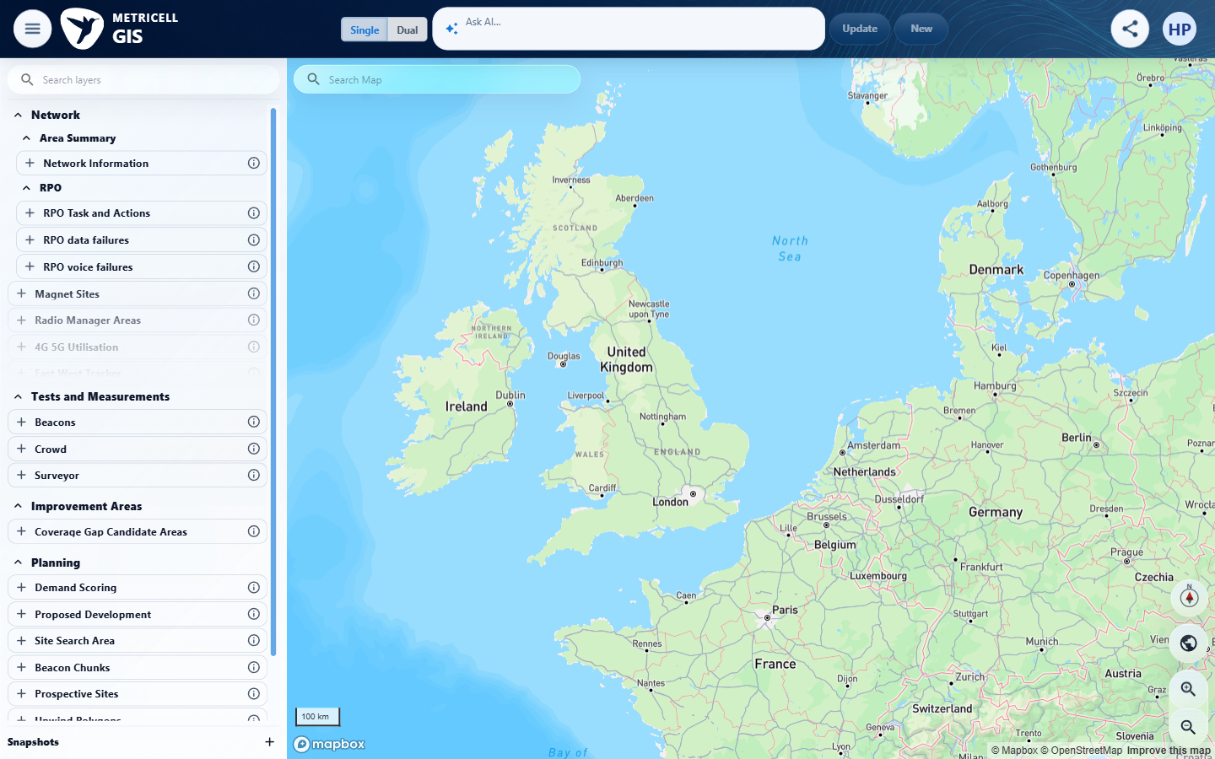
Figure 1: Select Open GIS on the GIS card in the V4 launcher.
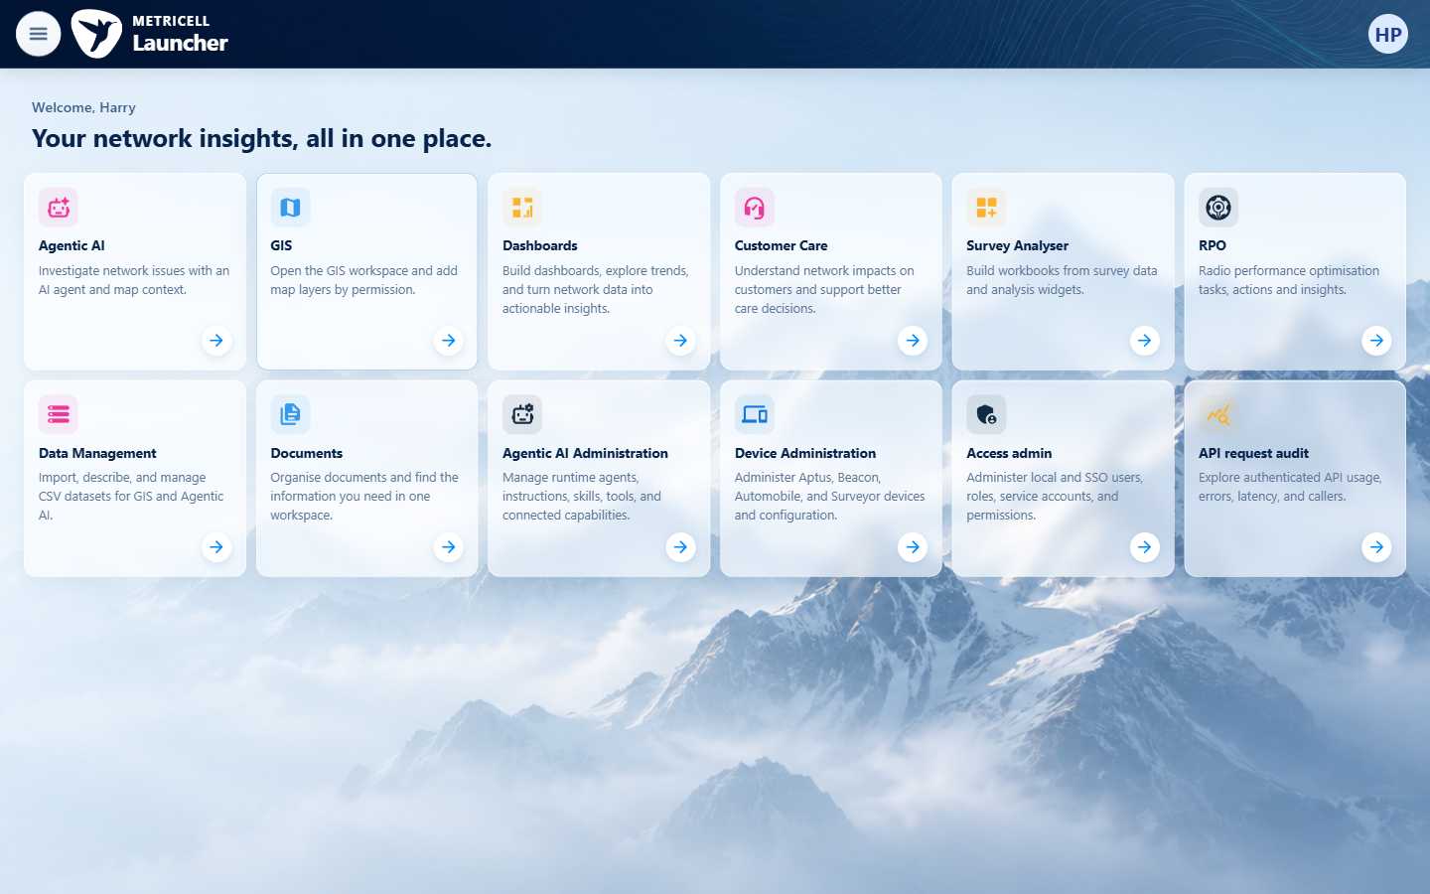
Figure 2: Use the browser Back control to return to the V4 launcher.

Updated guidance: Navigate from the V4 launcher to Agentic AI
Section: Navigating the V4 launcher and opening Agentic AI
1. Open the V4 launcher.
2. Select Open on the Agentic AI module card.
3. Confirm that the Agentic AI module opens at /agentic-ai.
4. Use your browser's Back button to return to the launcher.
5. Confirm that the launcher returns at /launcher with its module cards available.
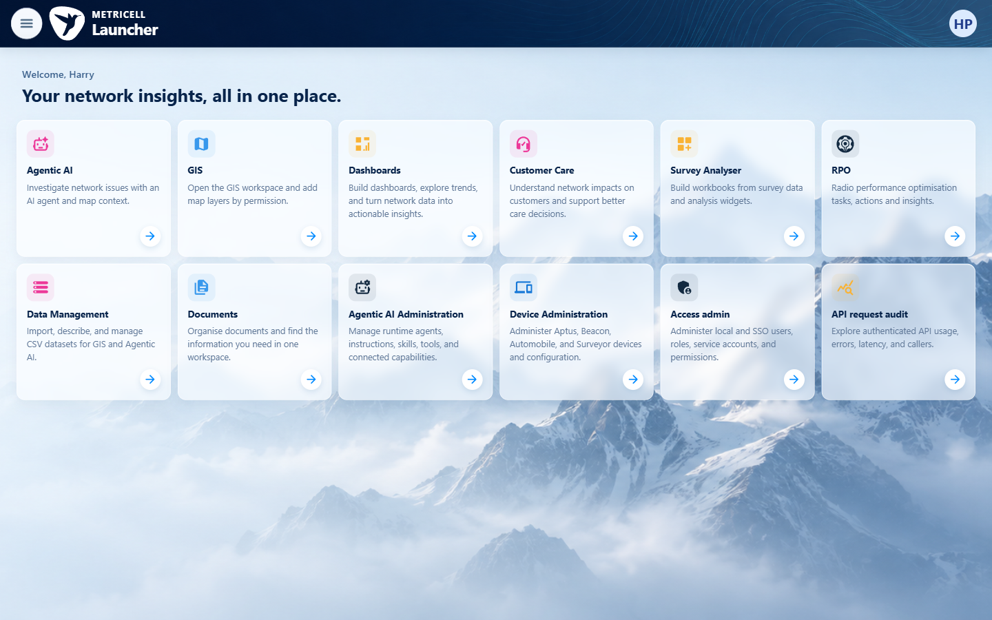
Figure 1: Open the V4 launcher.
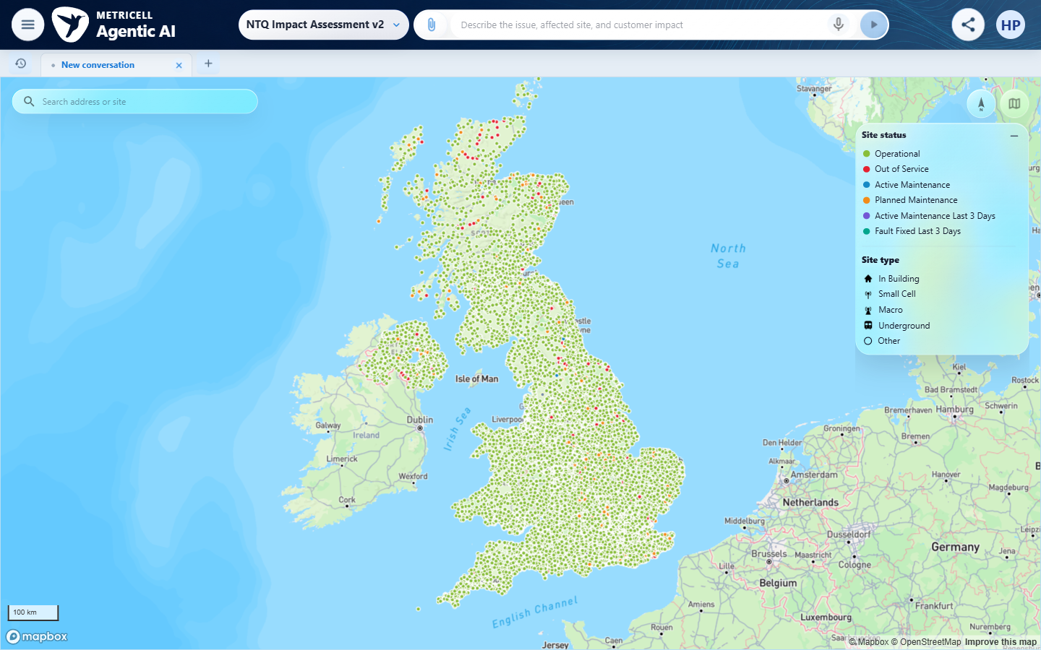
Figure 2: Select Open on the Agentic AI module card.
Figure 3: Confirm that the Agentic AI module opens at /agentic-ai.

Updated guidance: Open GIS from the V4 launcher
Section: Opening GIS from the V4 launcher
1. Open the V4 launcher.
2. Select Open GIS on the GIS module card.
3. Wait for the GIS page and map to load.
4. Select the browser Back button to return to the launcher.
Figure 1: Open the V4 launcher.
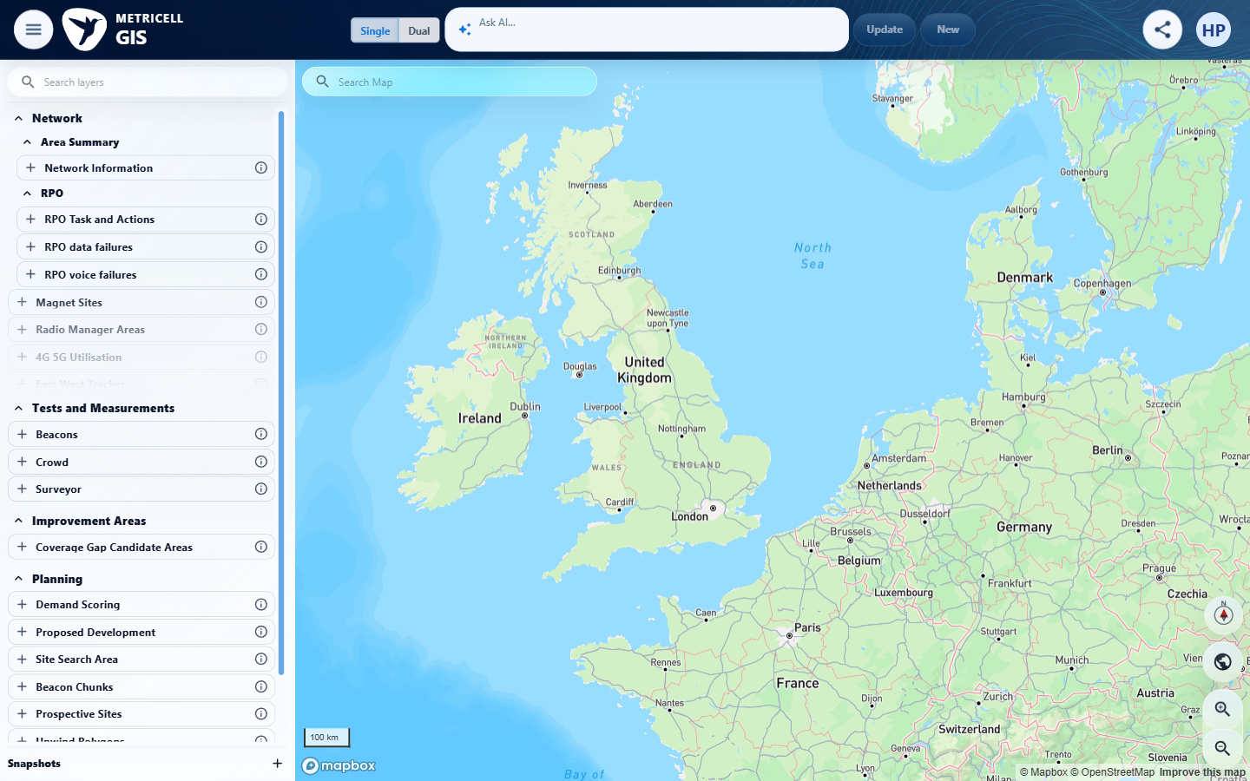
Figure 2: Select Open GIS on the GIS module card.
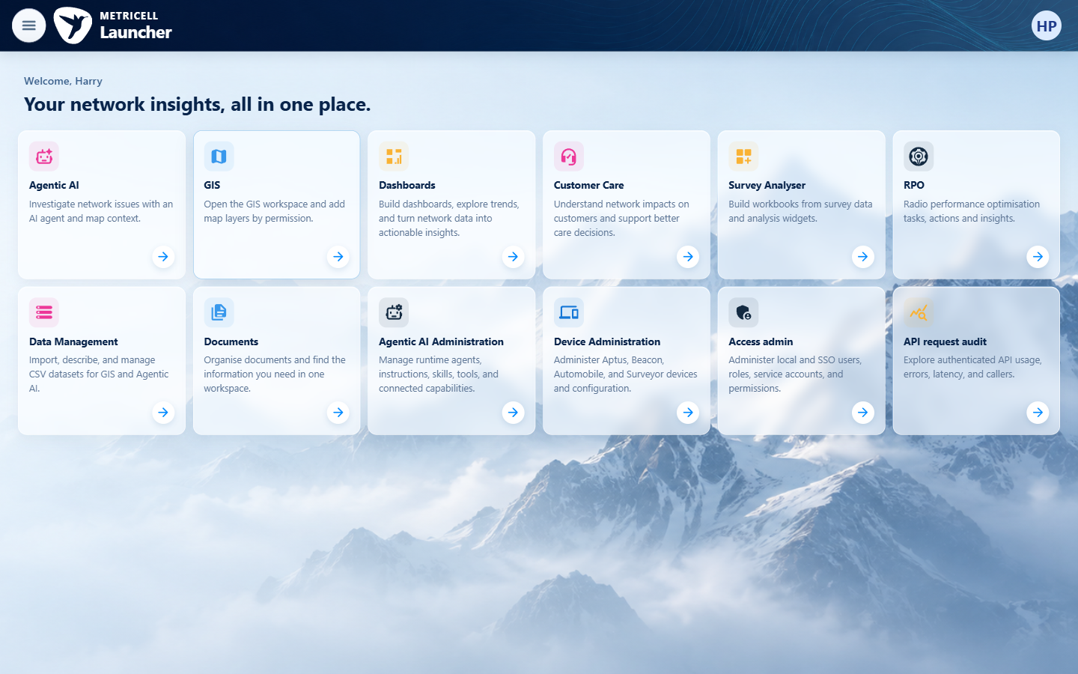
Figure 3: Wait for the GIS page and map to load.

Updated guidance: Open Dashboards and return to the launcher
Section: Dashboards: accessing the module and returning to the launcher
1. Open the Dashboards module from the launcher.
2. Confirm that the Dashboards page shows the Under construction message.
3. Select Back to Launcher to return to the launcher.
Figure 1: Open the Dashboards module from the launcher.
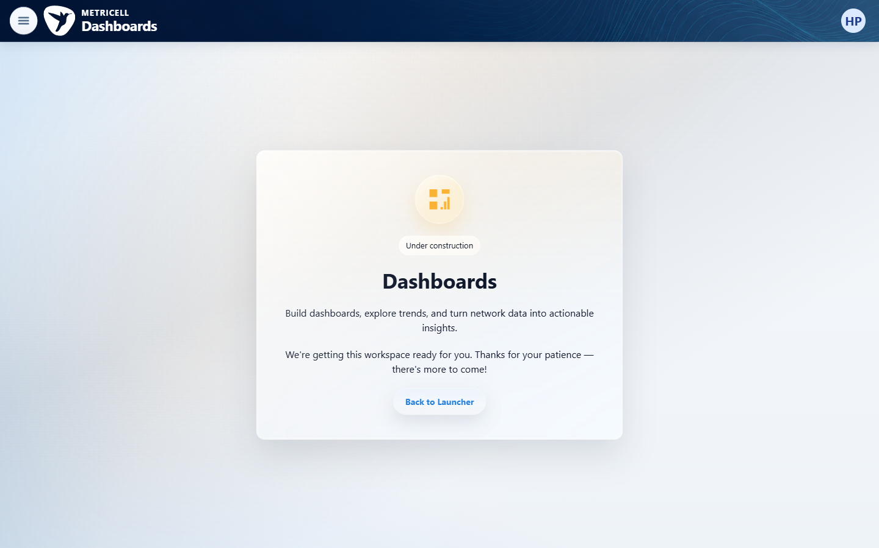
Figure 2: Confirm that the Dashboards page shows the Under construction message.
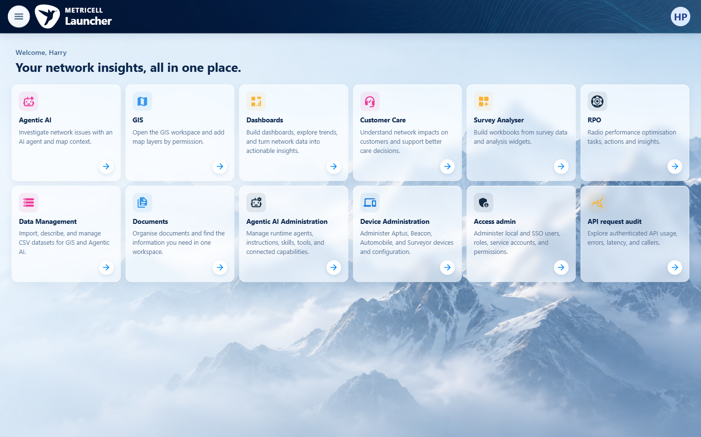
Figure 3: Select Back to Launcher to return to the launcher.

End of example guide. Review this document against the target V4 deployment before issuing it as an official manual.

